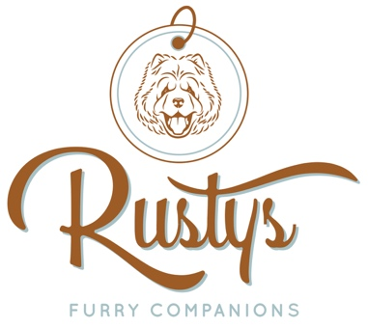

Behavioral Wellness Consultation Agreement
Rusty’s Furry Companions | Behavioral Wellness
Phone: 813-733-8551
Service Location: Pasco, Hillsborough County, FL

1. Parties and Scope
This agreement is between Rusty’s Furry Companions dba ("Consultant") and _________________________ ("Client"). This agreement pertains to behavior consulting services for the animal(s) listed below:
- Pet Name(s): __________________________________________________

2. Nature of Services
Client acknowledges that behavioral modification is not a guaranteed science. Behavior modification involves the collaborative effort of the Consultant, the Client, and the pet. Consultant provides expert guidance and protocols, but the efficacy of these protocols is dependent on the Client’s consistent adherence to the provided plan.

3. Risk Disclosure & Assumption of Risk
The Client understands that animal behavior can be unpredictable.
- Inherent Risks: Working with pets, particularly those exhibiting behavioral challenges, carries inherent risks including, but not limited to, bites, scratches, property damage, and the potential for a pet to escape.
- Assumption of Liability: The Client assumes full responsibility for any injury, damage, or loss caused by their pet while under the Client’s supervision, or while the pet is in the presence of the Consultant.
- Medical Clearance: The Client confirms the pet has been cleared by a veterinarian to rule out underlying medical causes for the behavioral issues.

4. Indemnification
The Client agrees to indemnify, defend, and hold harmless Rusty’s Furry Companions, dba, its owners, employees, and agents, from any and all claims, damages, liabilities, or expenses (including reasonable attorney fees) arising out of or related to the pet's behavior, actions, or medical conditions, except in cases of gross negligence or willful misconduct by the Consultant.

5. Methodology & Animal Welfare
Consultant utilizes LIMA-compliant protocols (Least Intrusive, Minimally Aversive).
- Equipment: Only equipment discussed and approved in the Behavioral Wellness Plan shall be used.
- Prohibited Methods: Use of punishment-based tools or techniques not previously authorized in writing by the Consultant is prohibited during this engagement.

6. Hillsborough County "Truth-in-Training" Compliance
- Training Plan: A written Behavioral Wellness Plan detailing the goals, methods, and equipment has been provided to the Client.
- Acknowledgment: Client acknowledges receipt of the Hillsborough County Consumer Acknowledgment Form. This will be emailed to owner.

7. Cancellation & Payment Policy
- Sessions: Payment is due at the time of the appointment. This will be non-refundable
- Cancellations: Cancellations require 48-hour notice. Sessions canceled within 48 hours are subject to an additional late-cancellation fee of 50% of the invoice.

8. Signatures
By signing below, the Client confirms they have read, understood, and agreed to the terms of this agreement and the behavioral protocols outlined in the attached Training Plan.
Client Signature: __________________________________ Date: ___________
Consultant Signature: _____________________________ Date: ___________
I certify that ___________________ has had a wellness exam within the last 6 months and is cleared for behavior modification. ______ (initials from owner).

